ALZHEIMER DISEASE
Alzheimer disease (AD), first characterized by Alois Alzheimer in 1907, is a gradually progressive dementia affecting cognition, behavior, and functional status.
Alzheimer disease profoundly affects the family as well as the patient
ETIOLOGY
The exact etiology of AD is unknown
GENETICS
More than half of early-onset, dominantly inherited cases of AD can be attributed to alterations on chromosomes 1, 14, or 21. These alterations largely impact the processing of a large membrane protein called amyloid precursor protein (APP). Amyloid precursor protein is typically broken down by three major secretase enzymes—α-, β-, and γ-secretase—into nonpathologic fragments as well as potentially pathologic 38 to 43 peptide-long β-amyloid peptide (Aβ) fragments
ENVIRONMENTAL AND OTHER FACTORS
A number of factors are associated with an increased risk of AD, including age, decreased reserve capacity of the brain (eg, reduced brain size, low educational level, reduced mental and physical activity), head injury, Down syndrome, depression, mild cognitive impairment (MCI), and risk factors for vascular disease (eg, hypercholesterolemia, hypertension, atherosclerosis, coronary heart disease, smoking, elevated homocysteine, obesity, metabolic syndrome, diabetes)
PATHOPHYSIOLOGY
- Signature findings include intracellular neurofibrillary tangles (NFTs), extracellular amyloid plaques in the cortex and medial temporal lobe, and degeneration of neurons and synapses and cortical atrophy. Density of NFTs correlates with severity of dementia.
- Proposed mechanisms for these changes include –
(1) β-amyloid protein aggregation, leading to formation of plaques;
(2) hyperphosphorylation of tau protein, leading to NFTs; (The tau proteins are a group of six highly soluble protein isoforms produced by alternative splicing from the gene MAPT (microtubule-associated protein tau).
(3) synaptic failure and depletion of neurotrophins and neurotransmitters;
(4) mitochondrial dysfunction; and
(5) oxidative stress.
- Of neurotransmitter deficits, loss of cholinergic activity is most prominent, and it correlates with AD severity. Cholinergic cell loss seems to be a consequence of AD pathology, not the cause of it.
- Other neurotransmitter considerations include the following:
(1) Serotonergic neurons of the raphe nuclei and noradrenergic cells of the locus coeruleus are lost;
(2) monoamine oxidase type B activity is increased;
(3) glutamate pathways of the cortex and limbic structures are abnormal; and
4) excitatory neurotransmitters, including glutamate, may be neurotoxic in AD.

STAGES OF AD-
Mild (MMSE score 26–21)- Patient has difficulty remembering recent events. Ability to manage finances, prepare food, and carry out other household activities declines. May get lost while driving. Begins to withdraw from difficult tasks and to give up hobbies. May deny memory problems
Moderate (MMSE score 20–10)- Patient requires assistance with activities of daily living. Frequently disoriented with regard to time (date, year, and season). Recall of recent events is severely impaired. May forget some details of past life events and names of family and friends. Functioning may fluctuate from day to day. Patient generally denies problems. May become suspicious or tearful. Loses ability to drive safely. Agitation, paranoia, and delusions are common.
Severe (MMSE score 9–0)- Patient loses ability to speak, walk, and feed self. Incontinent of urine and feces. Requires care 24 hours a day, 7 days a week.
CLINICAL PRESENTATION
GENERAL
The patient may have vague memory complaints initially, or the patient’s significant other may report that the patient is “forgetful.” Cognitive decline is gradual over the course of illness. Behavioral disturbances may be present in moderate stages. Loss of daily function is common in advanced stages.
SYMPTOMS
COGNITIVE-
- Memory loss (poor recall and losing items)
- Aphasia (circumlocution and anomia)
- Apraxia
- Agnosia
- Disorientation (impaired perception of time and unable to recognize familiar people)
- Impaired executive function
NEUROPSYCHIATRIC
- Depression, psychotic symptoms (hallucinations and delusions)
- Behavioral disturbances (physical and verbal aggression, motor hyperactivity, uncooperativeness, wandering, repetitive mannerisms and activities, and combativeness)
FUNCTIONAL
- Inability to care for self (dressing, bathing, toileting, and eating)
DIAGNOSTIC TEST
LABORATORY TESTS
- Rule out vitamin B12 deficiency with serum vitamin B12 testing
- Rule out hypothyroidism and hyperthyroidism with thyroid function tests
- Rules out anemia and infection with complete blood cell count
- Rule out electrolyte and glucose abnormalities and renal and hepatic dysfunction with a comprehensive metabolic panel
- Rule out syphilis with rapid plasma reagin testing
- Rule out human immunodeficiency virus (HIV) with HIV testing
OTHER DIAGNOSTIC TESTS
- Computed tomography (CT) or magnetic resonance imaging (MRI) scans may aid diagnosis
TREATMENT
GOAL OF THERAPY
- To symptomatically treat cognitive difficulties
- Preserve patient function for as long as possible.
- Secondary goals include managing psychiatric and behavioral sequelae.
- Current AD treatments have not been shown to prolong life, cure AD, or halt or reverse the pathophysiologic processes of the disorder.
APPROACH TO TREATMENT
- Prior to initiating treatment for AD, a thorough medication review should be completed.
- Benzodiazepines and other sedative hypnotics, anticholinergics, and antipsychotics have been associated with cognitive impairment.
- In addition, H2 -receptor antagonists, corticosteroids, and opioids like meperidine have been implicated in cases of delirium or acute cognitive change. Because medications are a reversible cause of cognitive symptoms, medication review and management are essential.
NON- PHARMACOLOGICAL TREATMENT-
The vascular health of the blood vessels in the brain is vital for cognitive function. To promote vascular health:
- Keep blood glucose, blood pressure and cholesterol well- controlled.
- Engage in “thinking" activities and regular physical activity (in all age groups, physical activity enhances the growth and survival of brain cells).
- Eat a healthy diet, with fruits, vegetables, nuts, fish and with a low intake of red meat and alcohol.
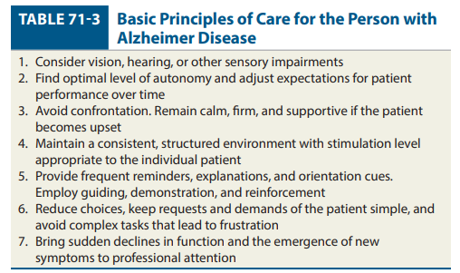

PHARMACOLOGIC THERAPY
PHARMACOTHERAPY FOR COGNITIVE SYMPTOMS
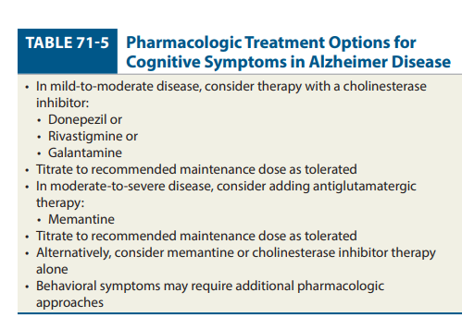
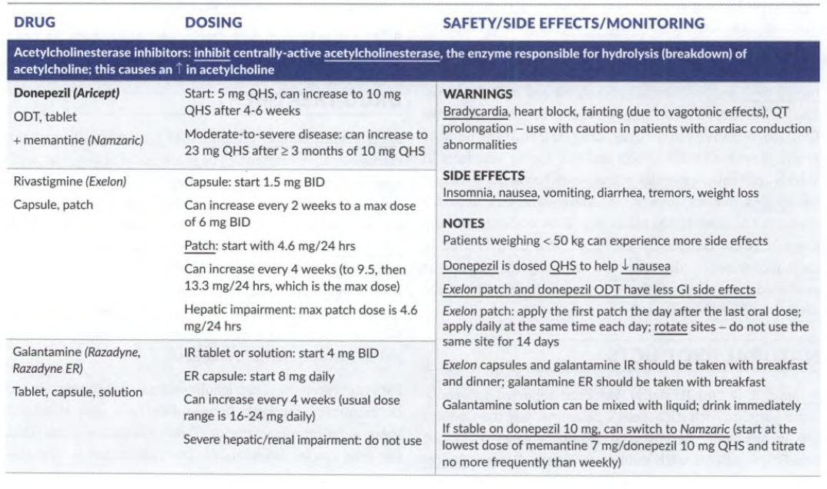
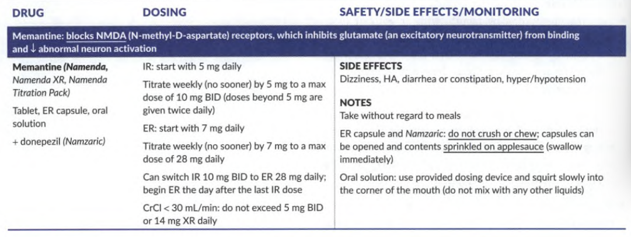
Rivastigmine-
DOSE-
Initial Dose- 1.5 mg twice daily (capsule, oral solution)
4.6 mg/day (transdermal patch)
USUAL RANGE
3-6 mg twice a day (capsule, oral solution)
9.5-13.3 mg/day (transdermal patch
ADR- Allergic Dermatitis
Galantamine
DOSE-
INITIAL DOSE- 4 mg twice daily (tablet, oral solution)
8 mg daily in the morning (extended-release capsule)
USUAL RANGE- 8-12 mg twice a day (tablet, oral solution)
16-24 mg (extended- release capsule)
ADR- Serious skin reactions (Stevens-Johnson syndrome and acute generalized exanthematous pustulosis)
